The Public Works Department is scheduled to collect residential leaves from City streets during the following three time periods:

October 23rd – 27th

November 13th – 17th

December 4th – 8th

Please be aware that the maintenance crew will NOT be scheduled to pickup leaves outside of these three scheduled periods. Leaves will not be picked up on Private or Dead End Streets.

The Leaf Pick-Up Program is provided by the Public Works Department as a free service to residents within the City limits.

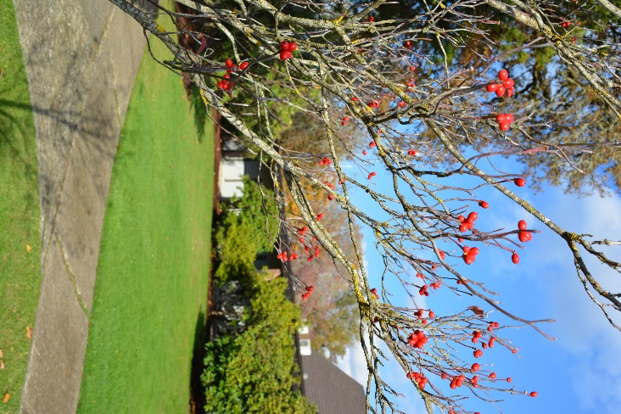

After December 4th, 2023, property owners will be responsible for removing any leaves left in front of their homes.
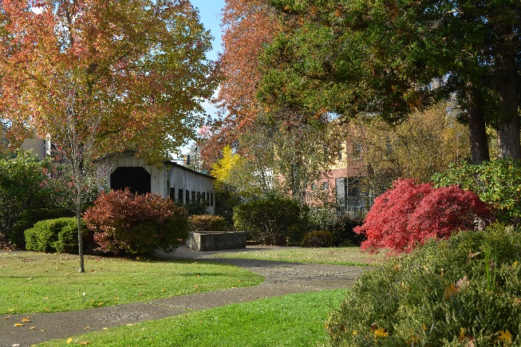

In order to minimize the time that leaf piles are in the street affecting parking and drainage, please put the leaves out on the weekend immediately preceding the first day of each pickup period.
………………………………………………………………....
If you have any questions, please contact the Public Works office at (541) 767-4100.
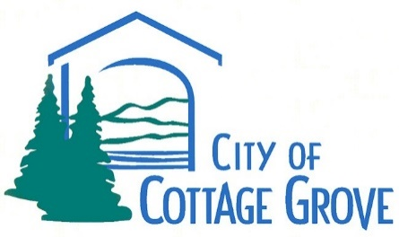

Annual
Leaf Pick-Up
Beginning
October 23, 2023
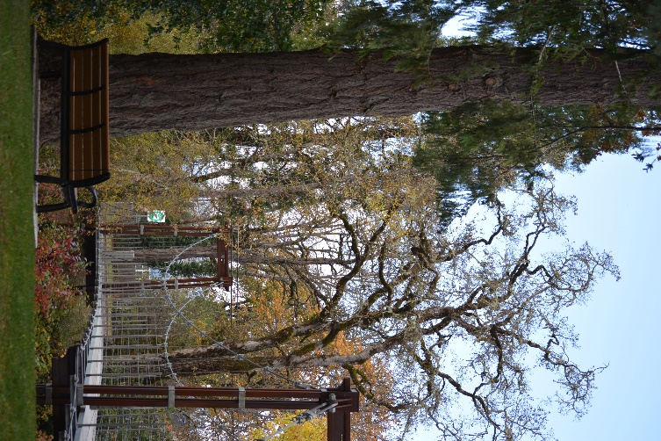

C
2023 Pickup Dates: October 23rd – 27th November 13th – 17th December 4th – 8th

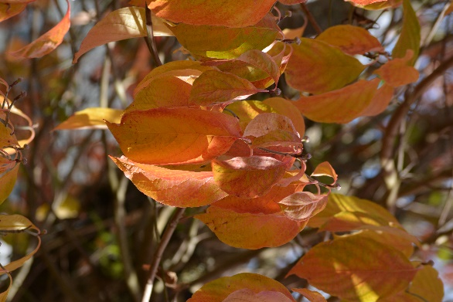

City of Cottage Grove Leaf Pickup
Residential leaf pickup is provided by the Public Works Department as a free service to City residents.

Leaves will be picked up during the three time periods shown in this brochure.

Leaf pickup will be accomplished with a truck and Titan Leaf Vac. This equipment cannot access DEAD END or PRIVATE Streets. Please place leaves at the closest intersection to the Dead End Street and clear of all street signs.

Leaf piles that are stacked under or very close to parked cars cannot be picked up.

Tips for Leaf Placement in Street
Pile leaves on the street surface near the gutter, keeping gutter and catch basins free of leaves so storm water is not obstructed.
On streets without curbs and gutters, pile the leaves near the street surface away from ditches.

Stack the leaves so that they don’t block bike and traffic lanes.
Leaves should be piled in rows so they do not block the flow of water along the curb and do not encroach on the traffic lane.
Do not place leaves in the streets where curbside parking does not exist. You may bring those leaves to the designated area outside the Row River Water Treatment Plant at 3300 Row River Road or one of the pullouts on River Road through December 8th, 2023.

Safety Issues
Property owners are responsible for any hazard they create by placing leaves in the streets.
Care should be taken that leaves do not create a hazard for bicyclists & motorists or restrict street drainage.

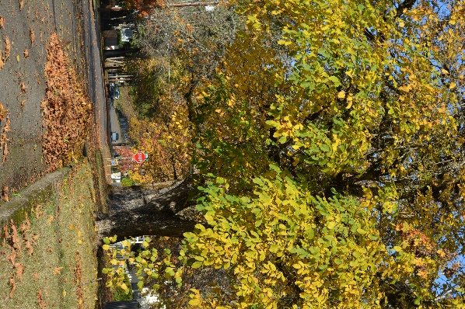

- Do not place your leaves in plastic bags.
- Branches will NOT be picked up.
- Shrub prunings & blackberry vines will NOT be picked up.
- Do NOT include rocks, metal or other debris in your leaf pile.
- Lawn clippings will NOT be picked up.

Only piles of loose leaves will be picked up.

